# **Validation Report Cost-Obj**

## *Summary Report*

*OBJECT*

IfcWall.NOTDEFINED

GlobalId: 3qgEayMZ55yxnk8LFa1i69

Obj Name: Muro di base:MUR_STR_CA_30_CA30:139503

*COST ITEM*

IfcCostItem

Price List Code: OC.EEA.a02.E9700.Sb017.0255.-

GlobalId: 3wrjbaA$DCSxztP1z$$LP4

Cost Name: Rebar Installation

*CHART*

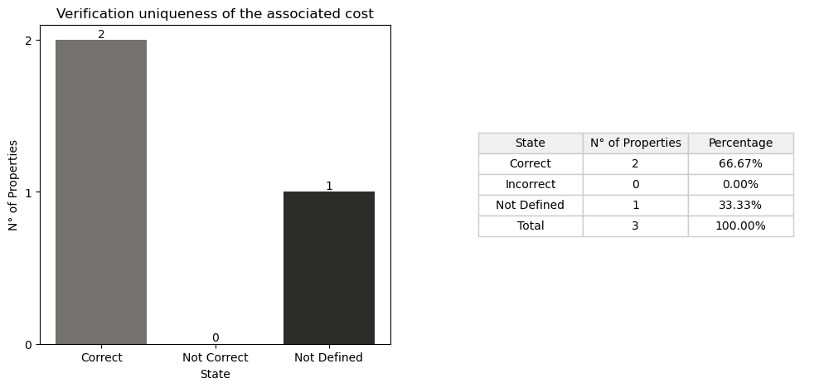

## *Detail Table*

|  |  |  |
| --- | --- | --- |
| **State** | **N° of Properties** | **Properties** |
| Correct | 2 | ReinforcementStrengthClass ConstructionMethod |
| Incorrect | 0 |  |
| Not Defined in the obj | 1 | Status |
| Not Defined in the cost | 0 |  |
| Not Defined in the cost and obj | 0 |  |

## *Detail Report*

**🔸Number of Correct Properties: 2**

ReinforcementStrengthClass: ✓   
 • #60=IfcPropertySingleValue('ReinforcementStrengthClass','Classification of the reinforcement strength in accordance with the concrete design code which is applied in the project. The reinforcing strength class often combines strength and ductility.',IfcLabel('B450C'),$)   
 • #3882=IfcPropertySingleValue('ReinforcementStrengthClass',$,IfcLabel('B450C'),$)   
  
ConstructionMethod: ✓   
 • In Situ

**🔸Number of Incorrect Properties: 0**

**🔸Number of Not Defined Properties in Obj: 1**

Status: ✗   
 • property not found in OBJ

**🔸Number of Not Defined Properties in Cost Item: 0**

**🔸Number of Not Defined Properties in Cost Item and Obj: 0**